

Behavioral Health Counselor

University of Colorado | College of Nursing | Sheridan Health Services

# The College of Nursing invites candidates to apply for the position of Licensed or Unlicensed Behavioral Health Counselor. The successful candidate will be a bilingual Spanish/English mental health provider that will provide outpatient behavioral health services to adults and adolescents at our Federally Qualified Health Center at 3525 West Oxford Avenue, Denver, CO 80236. This position is clinic based as a health care provider, 40 hours per week (1.0 FTE), benefits eligible, and is hired at the level of a clinical practice track Instructor within the College of Nursing.

Strong candidates will demonstrate a commitment to care delivery that incorporates a social justice perspective around the intersectionality of racism, sexism, classism, heterosexism, and other forms of oppression. This commitment is evidenced through the ability to discuss social determinants of health, awareness of self in relation to others, and providing treatment that incorporates socioecological theory.

**Examples of Work Performed:**

* Provide general outpatient behavioral health treatment via individual, group and family therapy, case management, crisis management, skill building, and psycho-education to adults and adolescents.
* Provide case management and care coordination with providers of service including but not limited to primary care providers, school personnel, family members, and other mental health and community partners.
* Evaluate crisis situations and take appropriate action to ensure client safety and the safety of all clinic users.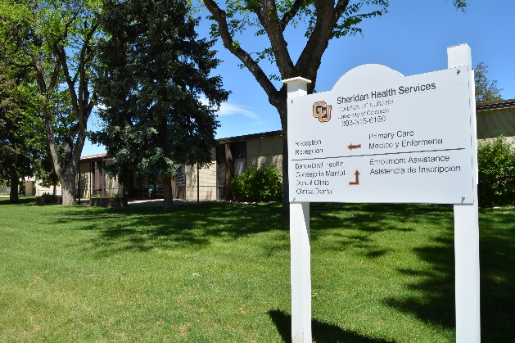
* Complete all required clinical and administrative documentation to accepted standards of practice, accurately, legibly, and by established timelines on electronic health record system and paper as needed.
* Utilize best practices and provide all treatment within appropriate limits. Complete and follow through with financial and clinical information necessary to ensure reimbursement for provided services.
* Expected to demonstrate high quality customer service focus, good communication and professionalism with clinic users, co-workers and representatives from outside agencies and to enhance community relationships.

**Please refer to the position announcement posted at** <http://www.cu.edu/cu-careers/>. **Search for Job Number 10970 for the full list of job responsibilities and qualifications for the Licensed Behavioral Health Counselor and Job Number 11066 for the Unlicensed Behavioral Health Counselor position.**

# Sheridan Health Services (SHS) is a multi-site, nurse-managed federally qualified community health center, funded through the Health Resources and Services Administration (HRSA) Bureau of Primary Healthcare; and is a collaborative effort between the College of Nursing and the Sheridan School District. There are now ~40 employees at two convenient locations to serve community health needs primarily for residents of Sheridan, Englewood, and North Littleton. A school-based clinic is located in the Sheridan School District Administration building. The community health center is located in southwest Denver on the Fort Logan campus and provides services to adults. Services offered include primary care across the lifespan; prenatal and postpartum care, gynecology, dentistry, pharmacy, behavioral health, and outpatient substance abuse treatment. We extend the reach of the clinic through public health outreach where nursing students provide community outreach, health education, and home visitation services.

**Questions may be directed to Rod DeVriendt at** [**rod.devriendt@ucdenver.edu**](mailto:rod.devriendt@ucdenver.edu)**.**

*The University of Colorado is committed to diversity and equality in education and employment.*

*All applications will be held in confidence by the Search Committee until finalists are identified.*