
COUNSELING NEWS: FALL 2014

 The Mission of the Counseling program at the University of Colorado Denver is to educate competent counselors who value inclusion and prize diversity such that they are prepared to offer a continuum of mental health services across a variety of settings for the benefit of the community & society.

In This Issue!
Letter from Marlinda Hines-Sloan (p.2); Policy reminders (p.2); Letter from Program Representative Dr. Hipolito-Delgado (p. 3); Welcome, Dr. Allen (p.4); Note from Dr. Larsen (p.4); CSI News (p.6);Back to School Night (p.8); CACREP Update (p.9); Preparation: Comps/NCE (p.10); Faculty Updates (p.11); Faculty Publications/Presentations (p.12); News from ODI (p.14); GLBTI Faculty Council Symposium (p.16); Deadlines & Reminders (p.17); Important Websites (p.17); Important Professional Organizations (p.17-19); Upcoming Conferences (p.18-19); New! EDU (p. 21).

Mark your Calendar!!!
November 5, 5:00-8:00pm: Internship Fair and Mandatory Advising Meeting, TIVOLI 320s.
Practicum Application Deadlines: Feb. 15th for Summer, April 15th for Fall, and September 15th for Spring.
NEW! October 15: Deadline for submitting online Course Plans to http://bit.ly/1ggs8Kr (see details below)
October 18: National Counselor Exam (NCE) from 9am-1pm. Location NC 1535.
November 8: Comprehensive Exam (Comps) from 8am-Noon. Location NC 1539.

Welcome to the fall 2014 semester! The Counseling Faculty and Staff are excited about the upcoming academic year and hope that you all are off to a fantastic start to the semester. In particular we want to welcome new students who have started the program this fall and past summer; as you get started on this journey, we would like to offer a few tips and suggestions to help you successfully make your way through your program. These are useful even if you are a student who has been in the program for a little while!

- Review your PROGRAM HANDBOOK thoroughly and make it your best friend! When in doubt, first consult your Handbook; the answer is often there. If you are unable to find the answer in the manual, consult with your faculty mentor and/or Geneva Sarcedo.
- Make sure you have your planned program outlined and sent to Geneva Sarcedo and your faculty mentor. Later this fall, you will also be receiving a link to a survey where you will fill in your program plan. You will need to do this before you can register for spring classes. This helps us plan!
- In preparing your planned program, pay attention to the prerequisites for courses and make sure you are planning on taking courses in the order in which they are required. This will limit problems such as not being allowed into advanced courses because of missing prerequisites.
- Make sure you know who your FACULTY MENTOR is, let her or him know who you are, stay in touch, and utilize this resource for support.
- Utilize the official sources of information for University, SEHD, & Counseling information and updates (not Facebook or the “grapevine”).

LETTER FROM MARLINDA HINES-SLOAN, OUTGOING ACADEMIC ADVISOR
As with all situations in life, we are told “the only constant is change.” In that spirit, I would like to make you aware of a change with regard to your Academic Advising. I have been offered an opportunity to deepen and expand the student experience by transitioning to the Outreach and Recruitment Department of the School of Education & Human Development. Since I was instrumental in the recruitment of many of you, this is a natural fit for my skills and further growth with the School. You will, however, be in good hands. I would like to introduce you to Geneva Sarcedo, who will be filling my Advising role effective September 15, 2014.

Geneva Sarcedo has been an academic advisor at CU Denver in the School of Education & Human Development for 2 years now. Before coming the Denver, she worked as an advisor for the Student Support Services (SSS) and Educational Opportunity Program programs at University of California, Davis and the SSS program at University of California, Berkeley. In addition to working at CU Denver, she is also a PhD student in the Urban Ecologies program. Those professional experiences has influenced her research interests in campus climate, critical race theory (CRT) and whiteness in academic advising, and best practices for working with first-generation and low income college students. Please feel free to reach out to her via email (Geneva.sarcedo@ucdenver.edu), phone (303-315-6351), or set up an appointment. I know she is excited to work with you.

In closing, I would like to thank all of YOU for your decision to further your education at CU Denver, and allowing me to be part of your growth and development as future Counselors. It has been a pleasure and a privilege to serve you.

Sincerely, Marlinda Hines-Sloan, MA, NCC | Coordinator of Outreach and Recruitment

Important Program Policy Reminders:
New! Online Corse Plans Required At New Student Orientation, you completed a Course Sequence Plan and returned it to the Academic Advisor. Beginning Fall 2014, ALL STUDENTS ARE REQUIRED TO COMPLETE/UPDATE AN ONLINE COURSE PLAN BEFORE THEY CAN REGISTER FOR SPRING 2015 CLASSES. DEADLINE IS OCTOBER 15. Go to http://bit.ly/1ggs8Kr

Counseling Program Policy Exceptions (p. 18, Counseling Program Handbook, April 2013)
Students who want to be granted an exception to any of the policies in the Counseling Program Student Handbook must submit a written request to their faculty mentor stating the nature of the request, the rationale for the request, and must attach relevant documentation. Such requests must be submitted to faculty mentors a minimum of 7 days prior to the monthly faculty meeting (First and Third Wednesdays). Faculty as a whole will act on students’ policy exception requests. Be aware that absent of extraordinary circumstances, policies will not be waived.
Track Change Process: If after taking some introductory courses in the program, a student wishes to change specialty track area, the student must fill out the track change form (p. 39 of Program Manual), meet with the designated faculty mentor in person to discuss the desired change, and obtain appropriate signatures. A signed copy of this form must be submitted to the Student Services Center, Lawrence Street Center, Suite 701.
Pre-requisites: Students are responsible for reviewing the Counseling Program Handbook, catalog and schedule to be certain that all prerequisites for courses have been taken. Some courses may be offered only once per year, or every other year.
A LETTER FROM COUNSELING PROGRAM REPRESENTATIVE,
DR. CARLOS HIPOLITO-DELGADO:

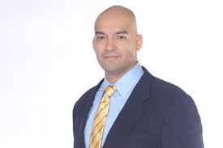

Greetings Counseling Students,

For our new students welcome to CU Denver and for our returning students, welcome back.

This letter marks one of my first actions as the new Program Representative for the Counseling Program. Though this new role will be challenging for me, I know I can count on the support of my colleagues and I look forward to representing the Counseling program in the School of Education and Human Development (SEHD) and the larger university. I want to also recognize the efforts of Dr. Diane Estrada—as Program Representative she was a champion for our program, faculty, and students—we all owe her a debt of gratitude.

I am also excited to announce the addition of Dr. Robert Allan to our faculty. Dr. Allan joins the SEHD as an Assistant Professor and will teach courses primarily in the Couples and Family Therapy. He has an exciting research agenda and we look forward to his contributions to the program. I can also share that the Counseling program was re-accredited by CACREP. The members of the CACREP site visit team were impressed with our program—particularly our commitment to issues of diversity and social justice. Congratulations to all the Counseling Faculty for making the re-accreditation process a success.

As a program we will continue to grow in 2014 – 2015. We will begin outreach and admission for our new Counseling track in Higher Education and Student Affairs (HESA). This new program is geared at professionals interested in working in Administration, Student Life, Academic Advising, Residential Life, and Student Programing in Higher Education settings. The HESA track has a strong focus on equity and access in Higher Education. We are also excited to be partnering with the Human Development and Family Relations (HDFR) program to offer undergraduate courses in Pre-Couples and Family Therapy and Pre-HESA. This Spring Dr. Poulsen will teach an undergraduate course in HDFR and Dr. Schaefle and I will teach cross-listed courses in HDFR and CPCE that will enroll both undergraduate and graduate students. These courses will be part of the HDFR undergraduate minor and major and are part of planned pipeline into our graduate degrees.

As the Counseling program grows, I hope that you take advantage of the fall semester as an opportunity to grow academically, professionally, and personally.

Carlos P. Hipolito-Delgado, Ph.D.
Associate Professor
University of Colorado Denver

President Association for Multicultural Counseling and Development



A Very Warm Welcome to: Robert Allan, Ph.D., Assistant Professor
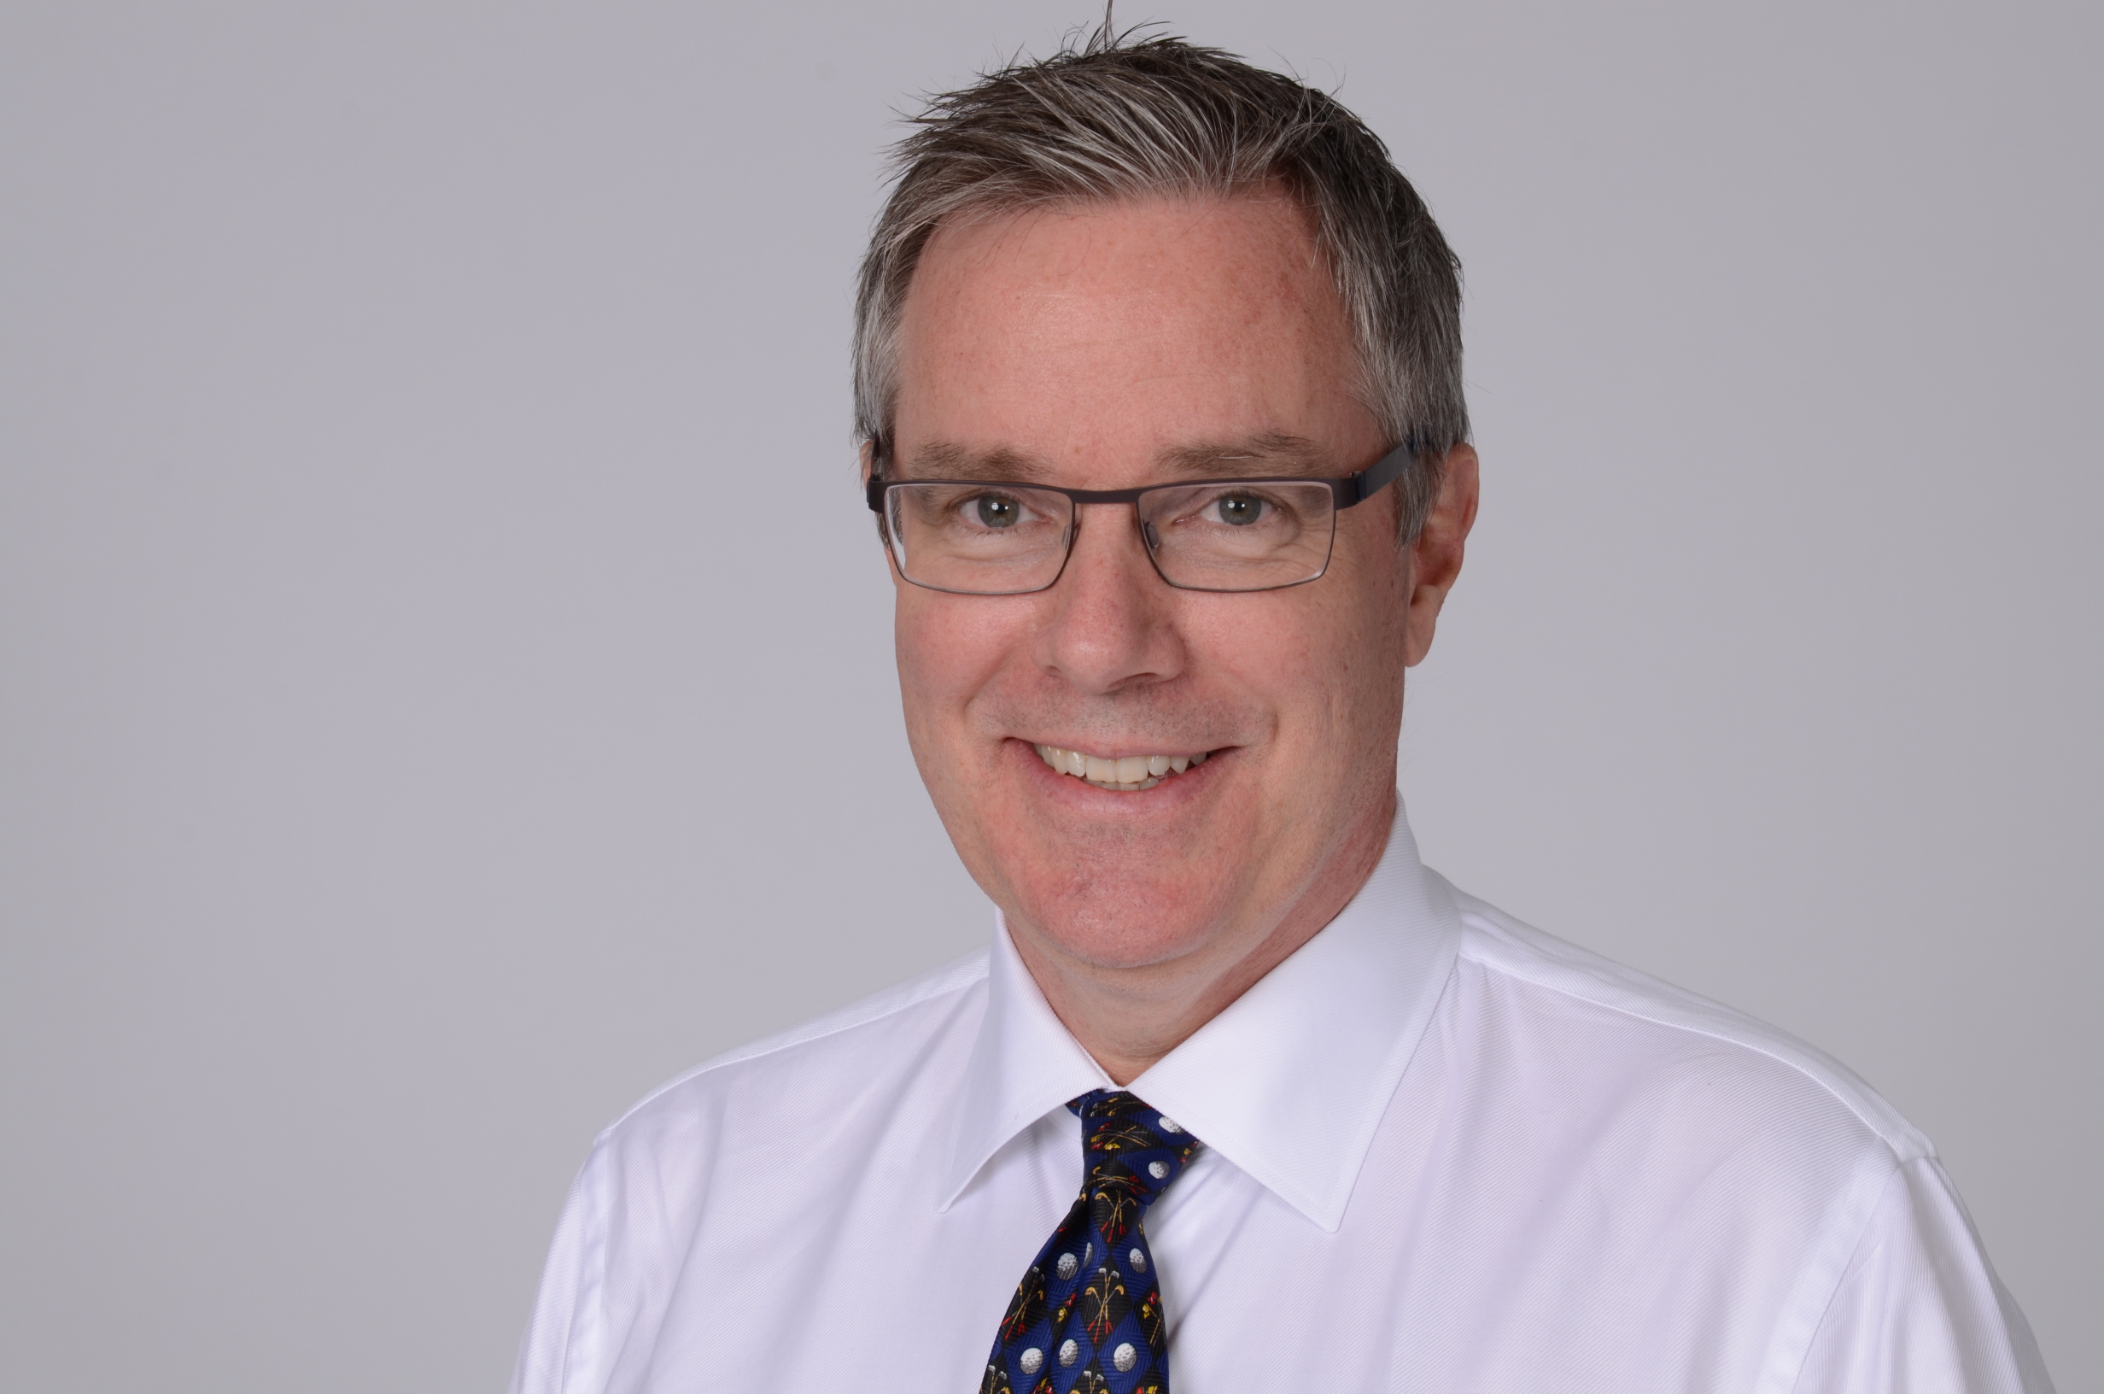 Dr. Robert Allan comes to us from Halifax, Nova Scotia where he recently completed a Ph.D. at Dalhousie University. His dissertation was a phenomenological exploration of couple and family therapists learning an evidence-based practice (http://hdl.handle.net/10222/52492). He joins the couple and family track. Dr. Robert Allan assisted Gail Palmer in the delivery of the fourth Core Skills training for Emotionally Focused Therapy in Halifax, Sept. 28-29, 2014.

A Recent Publication:
Allan, R. & Ungar, M. (2014). Developing a measure of fidelity for an ecological
approach to family therapy. Journal of Family Psychotherapy, 25(1), 1-16.
doi: 10.1080/08975353.2014.939931
http://www.tandfonline.com/doi/full/10.1080/08975353.2014.881688#.VAeAE010zcs
A Note from Dr. Pat Larsen, Clinic Director
What’s happening at the SCCC? (Student and Community Counseling Center)
Fall 2014 start up has been bustling and practicum caseloads are beginning to fill.
Here are some new developments:
The Center will soon be launching our new relaxation/quiet space. Students may use the room to take advantage of computerized biofeedback training, a massage chair, a water feature, meditative music and a prayer rug. Students may sign up for the space at 30 minute intervals throughout the day.
“Lulu” our wonderful canine assistant has launched her mental health column in the Advocate. Look for Lulu’s wise counsel on a regular basis!
The Center no longer has a session limit. The model is brief, goal directed and flexible depending on therapeutic need.
WOW is a new program . WOW stands for wellness on Wednesdays. In addition to our relaxation room, the Center hosts weekly workshops from 5-7 focused on enhance life skills. The current groups are STRESS LESS, RELATIONSHIPS, PEACE OF MIND, AND MANAGING YOUR MOOD. These are free and open to all CUDenver students (current clients and non clients).
The Center has secured funding to improve our signage in the Tivoli. Many have reported having difficulty finding our location in Tivoli 454. Our hope that the new signage will improve way finding for both on campus and off campus clients.
People at the Counseling Center you should know:
Christine Casey Perry has been promoted to her new role as Associate Director at the CU Denver Student and Community Counseling Center. A large part of that role is working to increase awareness of the Center’s services to staff, faculty and students at CU Denver, and expanding the Center’s use of technology with marketing and web-based therapeutic interventions. Christine continues to see a caseload of CU Denver students as clients at the Center, supervise practicum students and provide live observation of student sessions.
Ruth Possehl is a full-time Psychotherapist and Clinical Supervisor in the Counseling Center. She maintains a private practice and supervises masters’ level counselors for licensure. Ruth completed her masters in counseling at the University of Colorado Denver. Over the past 20 years, she has gained extensive experience counseling individuals, couples, families and groups. Areas of particular interest are: relationship issues, grief and loss and global mental health.
Heather Aberle After graduating from CU Denver in the Couple and Family Therapy track, I went back to work for the Safehouse as a women’s advocate. I later transitioned into working in a middle school exclusively with kids and families. While there, I was also able to train in how to do clinical supervision and started supervising interns. After a brief stint working for the insurance industry, I came to work for CU Denver fulfilling the dream I graduated with of coming back to the program and working in the practicum clinic supervising new counselors around how to work in a way that is multiculturally respectful.
Melody Brown I am full-time Clinical Supervisor and Psychotherapist at the Counseling Center. I also maintain a small private practice supervising marriage and family therapists. I am a licensed Marriage and Family Therapist and completed my master's degree in Marriage and Family Therapy at Louisiana University at Monroe, formerly Northeast Louisiana University. Over the last 14 years, I have specialized in working with adolescents, couples, and families and am passionate about issues of social justice in clinical practice.
Cynthia Chen is a licensed psychologist and has been an honorarium faculty member in the counseling program since returning to Denver. She is currently providing individual supervision for practicum students and teaching the Techniques of Counseling course. She is an alumnus of the program, having completed the couples and family track in 2006. She received her doctorate in counseling psychology from Boston College, and she also works at Children's Hospital Colorado. More personally, Cynthia is an avid Michigan football and professional tennis fanatic. In her free time, she enjoys cooking, baking, knitting, eating out with her friends, and learning to play the guitar.
Pat Larsen Pat served at a staff psychologist on Semester at Sea Summer 2014 voyage. SAS is a floating university that hosts a study abroad semester for 500 college students from over 200 different colleges and universities. Students are both US citizens and international students. Instead of studying in one county, the program sailed to 11 different counties this summer: England, Portugal, Spain, Ireland, Scotland, Norway, Sweden, Russia, Finland, Estonia, and Poland! While on the ship, students have classes every day. In port, they participate in organized field labs and trips as well as volunteer humanitarian projects. They also have the option to travel independently. If anyone has interest in learning more about this incredible opportunity to serve as a mental health professional on Semester at Sea, please contact Pat. pat.larsen@ucdenver.edu

 Chi Sigma Iota News

Welcome back to school from the officers at Chi Sigma Iota, Beta Alpha Omega Chapter! We are the Counseling Honor Society, and we have many exciting events and activities planned for this year. Please contact one of the officers if you would like to get involved!
What is CSI?
CSI is an international honor society that values academic and professional excellence in counseling. We promote a strong professional identity through members (professional counselors, counselor educators, and students) who contribute to the realization of a healthy society by fostering wellness and human dignity. www.csi-net.org
The local CSI chapter, Beta Alpha Omega, is comprised of students and alumni from the counseling program and is very active. Counseling students with 9 or more credit hours and a 3.5 or better GPA are eligible. All students are encouraged to contact the current CSI president for more information: Meghan.epstein@ucdenver.edu
Why join CSI-BAO? This year, CSI-BAO is offering a ton of member benefits, including:
*Scholarships to attend a professional conference (including the ACA Conference)
*Networking opportunities
*A chance to engage with the local community
*A Counseling Program graduation ceremony
*List yourself as a member of an internationally-recognized honor society
…and lots more!
Not a member of CSI-BAO? Please note that there are two applications to join: national through the website: http://www.csi-net.org/displaycommon.cfm?an=1&subarticlenbr=689, $50 (some goes back to local chapter), and local dues through the application form, $20. Applicants must submit a transcript with their local membership application to Dr. Cannon in Lawrence Street room 1137! Please note that each year, members are required to perform a minimum of 5 hours of community service.

CSI Mission
Promoting excellence in the profession of counseling. Our mission is to promote scholarships, research, professionalism, leadership, advocacy, and excellence in counseling, and to recognize high attainment in the pursuit of academic and clinical excellence in the profession of counseling.

CSI Leadership team 2014-15
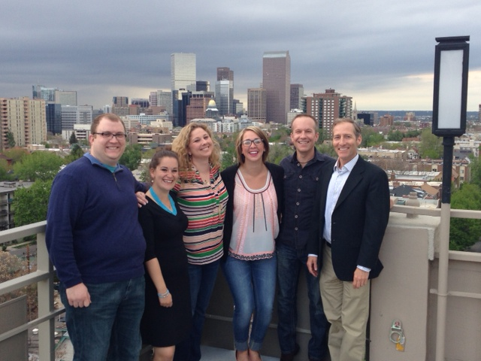
President: Meghan Epstein
President-elect: Star Hess
Past-President: Julie Miller
Treasurer: Jake Winchester
Secretary: Amy Rodrigue
School Track Rep: Kara Johnson
Couple/Family Track Rep: Katie Almond
Clinical MH Track Rep: Caroline Ritter
Multicultural Track Rep: Cara Hurley
Officers: Chris DiMarcella, Shayna Hill, Amanda Kister
Chapter Faculty Advisor: Dr. Edward Cannon

Fall 2014 CSI Events
(Note, you do not have to be a member to attend) Questions? Email us at chisigmaiotabao@gmail.com

Back to School Night- September 30 – Spill Lounge, 1410 Market Street, 5-10pm.
Community Engagement Day - Saturday October 11, 8am- 4pm. TIVOLI location tbd
Spirituality Workshop– Saturday November 8 9am-3pm. TIVOLI Senate Chambers, room 329
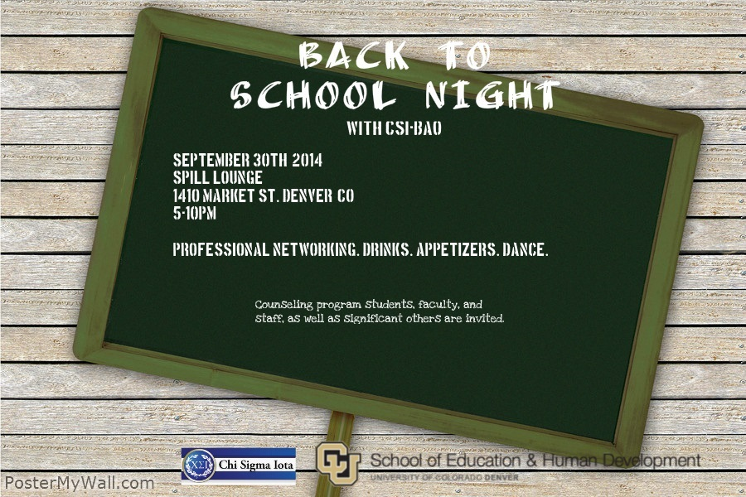

Counseling Program on Path to CACREP Re-Accreditation
What is CACREP?
CACREP is an independent agency recognized by the Council for Higher Education Accreditation to accredit master's degree programs in addiction counseling, career counseling, clinical mental health counseling, marriage, couple, and family counseling, school counseling and student affairs and college counseling.

Why Attend an Accredited Program?
- Be assured of the quality of your academic program.
- Research shows CACREP graduates perform better on the National Counselor Examination for Licensure and Certification (NCE).
- Streamlines the licensure application process.
- CACREP programs have been reviewed against
professionally approved standards.

After a year-long process, the counseling program faculty submitted its self-study to CACREP in July 2013. Once CACREP reviewed the document, they set up a site visit in February 2014. When the site visit occurred, representatives from CACREP interviewed faculty, students, outside stakeholders, and administrators about their experiences. We received a 2 year accreditation, and must meet some requirements, before gaining 7 year status in July 2016. For more information go to www.cacrep.org.
CACREP ESSAY CONTEST- WIN $$
PROFESSIONAL IDENTITY: CHALLENGES AND POSSIBLE SOLUTIONS
This year, CSI and CACREP are sponsoring a joint essay contest to promote a strong professional counselor identity. CSI members are invited to submit an essay on this topic in one of two membership
categories: Entry-Level Students and Doctoral Students/Professional Counselors/Counselor Educators. The first place winner in each category will receive $500, a one-year membership renewal in CSI, and publication of the essay in the CSI Exemplar, the CACREP Connection newsletter, and at csi-net.org! Prizes will also be awarded for second and third place winners within each membership category.
To read about the contest and submit an essay, go to http://cts.vresp.com/c/?CouncilforAccreditat/8cd4a772fd/a92cd65999/2950b86250/Essay_Contest.
The deadline to enter is November 15, 2014.
Preparing for Comprehensive/NCE Exams 

Some of you may have already started studying for the NCE and/or Comps, if so here are a few pointers…

Comprehensive Exams (comps)
Date: November 8, 2014 from 8am-12pm. Location NC1539.
Results Available: 2 weeks after exam
Number of Questions: 180

Procrastinators Beware: Do not take this exam the last semester of classes. If you do not pass, you will not graduate and you will have to register for 1 graduate credit (more money and fees!) in order to take it again.

National Counselor Exam (NCE)
Date: October 18, 2014 from 9am-1pm. Location NC 1535.
Number of Questions: 200, scored on 180 (20 are “test” questions that determine the next exam)
Results Available: approximately 6 weeks after exam
Emergency: if you cannot take the exam because of an emergency contact Marlinda Hines or Geneva Sarcedo so she can notify NBCC and let them know you will be taking it the next time.

Core Areas
1. Human Growth and Development
2. Social and Cultural Foundations
3. Helping Relationships
4. Group Work
5. Career and Lifestyle Development
6. Appraisal (measurement)
7. Research and Program Evaluation
8. Professional Orientation and Ethics

Study Materials – all materials in the clinic are available to check out. They are located on top of the video cabinet.
Book – $42.90, clinic has 1 copy available to check out
Encyclopedia of Counseling by Howard Rosenthal
CD’s – $84.73, clinic has a complete set, available to burn
Vital information and Review Questions for NCE and State Counseling Exams by Rosenthal
Counselor Exam Prep Workshop given by Dr. Helwig; visit www.counselor-exam-prep.com for more information.

 FACULTY UPDATES/ACTIVITIES/ACCOMPLISHMENTS
Dr. Edward Cannon continues his appointment to the Board of Licensed Professional Counselor Examiners. This is a board position that is appointed by the Governor of Colorado and an important and honorable role for one of our faculty to be involved in. He is also running for President-elect of the Association for LGBT Issues in Counseling, a Division of the American Counseling Association.
Dr. Diane Estrada is a member of the AMCD bylaws committee, as well as an Inclusiveness Committee member for the Mental Health of America Colorado Board. This committee was created to develop a plan to investigate the stigma of mental health in communities of color. The results of this study will increase our understanding of the types of services needed in the various communities to address mental health issues. Dr Estrada has also been invited to co-author a book chapter on advocacy with the LGBTQI populations titled "Becoming an Ally: Personal, Clinical and School-Based Social Justice Interventions.” Dr. Estrada is co-authoring a manuscript with a former student, Asher Eno, on “the Visible invisibility of Gender: Conversations in the classroom.”
Dr. Troyann Gentile continues to work on streamlining the internship paperwork and process. She continues to be an advocate and liaison between our program and our community partners, building additional networks and relationships in support of our students’ training. In addition she is serving as the Chair of the CUDenver GLBTI Faculty Assembly Committee, as well as Chair for the University of Colorado Faculty Council GLBTI Committee. As part of her role as chair of the Faculty Council committee, she is charged with fundraising and organizing the 3rd Annual CU System GLBTI Symposium, which is scheduled for November 7th, 2014 at the Anschutz Medical Campus. Dr. Gentile is slated to present at the Rocky Mountain Association for Counselor Education and Supervision Conference on topics of Socially Just Gatekeeping, and Social Justice and Diversity Throughout the Training Curriculum.
Dr. Carlos Hipolito-Delgado serves in the role of Counseling Program Representative for the 2014-15 academic year. As the Counseling Program Representative, Dr. Hipolito-Delgado is the contact/point person for overall Program communication. Dr. Carlos Hipolito-Delgado assumed the presidency of the Association for Multicultural Counseling and Development (AMCD) for the fiscal year of 2014 – 2015. His presidential campaign focuses on advance Multicultural Counseling and includes an update of the Multicultural Counseling Competencies and increased opportunities for professional development for AMCD members. In addition Dr. Hipolito-Delgado becomes the Counseling program representative for a two year term from 2014 – 2016. Dr. Hipolito-Delgado was also appointed to the American Counseling Association Foundation Board (ACAF). In his role on the ACAF Board he is responsible for raising funds for the foundations scholarship, grant, and awards that recognize the work of those who advance the counseling profession. Dr. Hipolito-Delgado’s research on ethnic identity labels was recently featured on the home page of CU Denver and the School of Education and Human Development websites. This also led to his research being featured by Telemundo Atlanta and the American Counseling Association (ACA)—Dr. Hipolito-Delgado was also featured in a short segment that ran on the Noticero (nightly news) program of Telemundo Denver. Dr. Hipolito-Delgado is also being featured in an ACA publicity campaign highlighting how ACA leaders advocate for the counseling profession. Finally, this past May Dr. Hipolito-Delgado was presented with a Faculty Assembly Award for Service for his efforts in developing the new Higher Education and Student Affairs track in the counseling program.
Dr. Farah Ibrahim Dr. Ibrahim is developing a course for the Human Development Program at the University of Colorado Denver on “Culture, Family, Gender, and Spirituality.” This is an undergraduate/graduate course, to be offered summer 2015. This is an innovative new major developed by Dr. Ruben Anguiano, program lead of the Human Development undergraduate and graduate programs, which was launched fall 2014. The most unique aspect of this major is the fact that it is the first bilingual (English/Spanish) Human Development Program in the country.
Dr. Shruti Poulsen will be the contact faculty member for the Couple and Family Track for academic year 2014-15. Dr. Poulsen has been selected by the American Association for Marriage & Family Therapy to be a Mentor in the AAMFT Minority Fellowship Program. Dr. Poulsen completed the Advanced Core Skills Training in Emotionally Focused Therapy (EFT), an empirically based modality for working with couples & families. Board Member: Colorado State Board of Marriage & Family Therapist Examiners (Governor Appointed). The SEHD Excellence in Service Award, School of Education & Human Development, 2014.
Dr. Scott Schaefle The seeds for my interest in counseling and counselor education were planted while I was working with court referred adolescents. Initially, my desire was to learn what I could do to become more effective in my interactions with the people with whom I worked. Gradually, I realized that while increasing my knowledge and skills about working with individuals was important, that systemic change was essential to the success of my clients. I am a firm believer in the benefits of early intervention, prevention, and systemic change. My goal is that my students are not only personally aware and clinically skilled but also committed and effective agents of systemic change.

Faculty Publications:

Allan, R. & Ungar, M. (2014). Developing a measure of fidelity for an ecological
approach to family therapy. Journal of Family Psychotherapy, 25(1), 1-16.
doi: 10.1080/08975353.2014.939931
http://www.tandfonline.com/doi/full/10.1080/08975353.2014.881688#.VAeAE010zcs

Cannon, E., Wiggins, M., Poulsen, S., & Estrada, D. (2012). Addressing heterosexist privilege during orientation: One Program’s Experience. Journal of LGBT Issues in Counseling, 6, 3-17. doi: 10.1080/15538605.2011.598225

Estrada, D., Poulsen, S., Cannon, E., & Wiggins, W. (2013). Orienting students towards multiculturalism: Exploring privilege during a new student orientation. Journal of Humanistic Counseling, 52, 80-91. doi: 10.1002/j.2161-1939.2013.00034.x

Hipolito-Delgado, C. P. (2014). Decoding the Ethnic Labels Used by Undergraduates of Latin American Descent. Journal of Humanistic Counseling, 53, 101 - 119. doi: 10.1002/j.2161-1939.2014.00052.x

Hipolito-Delgado, C. P., Gallegos Payan, S. & Baca, T. (2014). Self-hatred, self-doubt, and assimilation: Las consecuencias de colonización y opresión. In E. J. R. David (Ed.). Internalized oppression: The psychology of marginalized groups (pp. 109 – 136). New York: Springer.

Hipolito-Delgado, C. P. (April, 2014). Beyond cultural competence. Counseling Today. Pp. 50 – 55.

Ibrahim, Farah.

- Paper accepted on “International consultation and training on group work in South Asia” in the Journal for Specialists in Group Work, special issue on international group work, publication scheduled for Spring 2015.
- Text on “Social justice and cultural Responsiveness: Using cultural assessments with J. R. Heuer, is in the final stages for submission. The book is under contract with Springer Publications.

Poulsen, S.S. (2014). Assessment & Treatment: Making the Most of the
Genogram Process. Colorado Association for Marriage & Family Therapy Newsletter, Summer 2014.

Poulsen, S.S. (2014). Review of the book Interracial couples, intimacy, & therapy: Crossing racial borders, by K.D. Killian. Journal of Marital & Family Therapy.

Malott, K., & Schaefle, S. (In Press). Addressing clients’ experiences of racism: A model for clinical practice. Journal of Counseling and Development.

Malott, K., Paone, T., Schaefle, S., Cates, J., & Haizlip, B. (In Press). Expanding White racial identity theory: A qualitative investigation of Whites engaged in antiracist action. Journal of Counseling and Development.

Funded Grants
Hipolito-Delgado, C. P. and Estrada, D. (2014). The Lived Experience of Students of Color in Counselor Education: Implications for Recruitment and Retention. Funded $2,000 by the CU Denver Center for Faculty Development.

Kirshner, B., Mendoza, E., and Hipolito-Delgado, C. P. (2014). Critical Civic Inquiry Summer Institute. Funded $3,000 by the CU Diversity & Excellence Grant.

Kirshner, B., Zion, S., and Hipolito-Delgado, C. P. (2013-2014). AERA Research Conference Award: Sociopolitical Development, School Engagement, and Psychological Well-Being: Defining Terms and Assessing the Evidence- Base. Funded $31,408 by the American Educational Research Association.

Faculty Presentations: Completed & Upcoming
Poulsen, S.S. (June 2014). Presentation Moderator: American Family Therapy Academy 2014 Annual Meeting & Conference, University of Georgia, Athens, Georgia

Cannon, E., Frank, D. & Mills, J. (September 2014). Integrating LGBT Competencies in Counselor Education: Experiential Activities for Increasing Awareness and Knowledge. Presented at ALGBTIC Annual Conference, New Orleans, LA.

Cannon, E. (October 2013). The Gender Continuum and LGBTQ Issues in Addictions Treatment. Presented at Gender Matters Conference, Sponsored by the Center for Dependence, Addiction and Rehabilitation (CeDAR), Anschutz Medical Campus.

Hipolito-Delgado, C. P. & Reinders, R. (March 28 – March 30, 2014). Igniting the Fire in Marginalized Youth: Fostering Psychological Empowerment through Critical Civic Inquiry. Program presented at the national conference of the American Counseling Association. Honolulu, HI.
Ibrahim, Farah.
- Proposal prepared and submitted by Dr. Ibrahim to the Rocky Mountain Association for Counselor Education and Supervision on “Social justice and Diversity: The UCD Integrated Counselor Training Model.” The program will feature the full faculty at UCD addressing all three tracks: Clinical Mental Health, Couples and Family Therapy, and School and College Counseling. To be presented on October 4, 2014, in Jackson Hole, WY.
- Proposal accepted for the American Psychological Association’s National Multicultural Summit, on “Counseling South Asian Immigrants: Social Justice and Culturally Responsive Interventions: An overview.” Presentation scheduled for January 15-16, 2015, in Atlanta, GA.
- Presentation accepted for the American Counseling Association on “Cross-Cultural/Multicultural Counseling in the 21st Century.” Presenters include: Drs. Carlos Hipolito-Delgado, Allen Ivey, Joseph Trimble, Clemmont Vontress, and Farah Ibrahim. The presentation will be held on March 11-15, 2015, in Orlando, FL.

News from the SEHD Office of Diversity & Inclusion 
Welcome and Welcome Back! The University of Colorado School of Education and Human Development team is excited to have you as new or returning members of our community and I am personally looking forward to learning about the many ways we can support your success.
As you begin to settle into the 5th week of classes (what? 5th week) and learn about the exciting and provocative learning environment, please know, we are available to you.
By now I’m sure you’ve had a chance to meet your advisors, and realize they can be a wealth of knowledge and a wonderful support! In addition, we have a vibrant community of faculty, students and alumni who are passionate and excited to collaborate with you on a wide array of high-impact projects and engagements of your liking. Your ideas, energy, and talent are what will make your experience unique and we want to help you bring “life” to them!
Will Somebody ”PLEASE” listen?
Students entering any level of school in higher education, whether it be at the bachelor’s level, Masters, or Doctorate, face a variety of challenges. Research has found that meaningful mentoring relationships, pairing entering students with more advanced students, can assist in student transition and overall success.
Chi Sigma Iota (C.S.I.) Honor Society members, with the support of their Advisor, Dr. Edward Cannon, have launched a C.S.I. Mentor Program. This program is open to all Counseling students. Also, with the help of select C.S.I. members, the School of Education and Human Development is also creating a partner SEHD student mentor organization designed to collaborate with C.S.I. in serving all SEHD students.
Please remember your participation will produce meaningful relationships that foster educational encouragement, valuable personal connections, and ultimately lead to enhancing your professional network and support!

SEHD “Lunch with Students” - Community Engagement Series!
Out-to-lunch or Community Engagement: What is the “Lunch with Students” series?
An opportunity for two or more members of the SEHD student and faculty community to share light conversation over a meal. These are also informal opportunities to learn about each other and get to know each other in a stress-free environment. This experience is designed to promote SEHD “community”. Great conversations around hobbies, interest, adjusting to campus life, professional journeys, and simple life experiences are encouraged!
Students – please contact me if you are interested in partnering with the Office of Diversity and Inclusion to take a faculty member to lunch!
Resiliency in Fire: Finding your Voice
Community Event
Firefighters, Clinicians, students, and community members are encouraged to participate in this provocative mental health discussion with the Firefighting Community and clinicians.
Featured guest include Kim Lightley (from the infamous ’94 Storm King Fire) John Carr (with the Westminster Fire Department) and Karen Jackson, Ph.D. (Clinical Psychologist specializing in Trauma)
DATE: Oct 31, 2014
TIME: 9:30 – noon
LOCATION: Tivoli 320, 900 Auraria Parkway
CU Denver Students Free ($10 donation requested for others)
To R.S.V.P. or for more information please contact Anna Ivanova at 720-352-7648 or anna.ivanova@ucdenver.edu
And here’s your team…
This year’s Office of Diversity and Inclusion members come from the PsyD Program (Layla Schimmel), the C.P.C.E. Program (Chris DiMarcella), the School of Architecture (Samira Mohamed), and the College of Liberal Arts & Sciences (Andrew McMahon). Stop by, say hi, and remember - we look forward to 2014-15 with you in mind.
In the spirit of service!
Aswad Allen, PhD
Assistant Dean, Diversity & Inclusion
School of Education & Human Development | University of Colorado, Denver

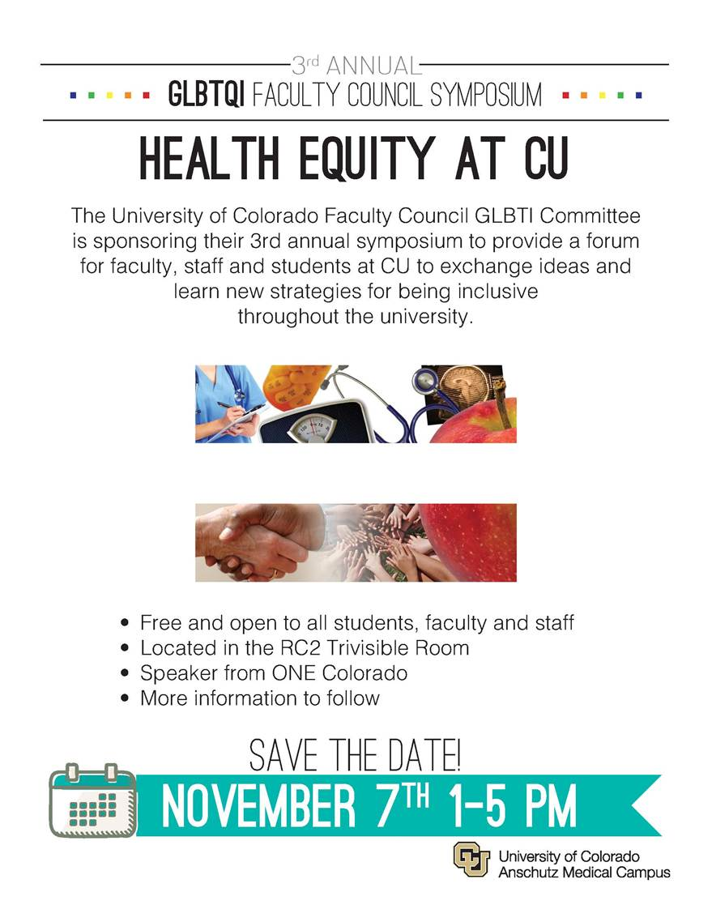
DEADLINES, REMINDERS, UPDATES & INFORMATION
Practicum Application Deadlines: February 15th for Summer, April 15th for Fall, and September 15th for Spring.
September 15th – Practicum and Internship Applications are due to Lethi Cussen at the Counseling Center in Tivoli 454. Forms can be found on the Counseling - Current Student Resource Page.
http://www.ucdenver.edu/academics/colleges/SchoolOfEducation/CurrentStudents/Resources/Pages/CounselingResources.aspx

November 5, 5-8pm: Internship Fair and Mandatory Advisement Meeting, TIVOLI 320s
Metro Counseling Services are available to CU Denver Counseling students; 10 free sessions per semester.
IMPORTANT WEBSITES!!!!! 

There are many valuable new websites to assist you in answering some of your basic questions about the program. We advise you to check them out!

- CPCE Current Student page
  - http://www.ucdenver.edu/academics/colleges/SchoolOfEducation/CurrentStudents/Resources/Pages/CounselingResources.aspx
- School Counseling page
  - https://sehd.ucdenver.edu/schoolcounseling/
- Internship page
  - http://sehd.ucdenver.edu/cpce-internships/

IMPORTANT PROFESSIONAL ORGANIZATIONS!!!!! 

The Association for Lesbian, Gay, Bisexual, and Transgender Issues in Counseling (ALGBTIC)
http://www.algbtic.org

ALGBTIC is a Division of the American Counseling Association. The mission of ALGBTIC includes the recognition of both individual and social contexts representing the confluence of race, ethnicity, class, gender, sexual orientation, ability, age, spiritual or religious belief system, indigenous heritage in order to promote greater awareness and understanding of lesbian, gay, bisexual, and transgender (LGBT) issues among members of the counseling profession and related helping occupations; and to improve standards and delivery of counseling services provided to LGBT clients and communities.

The American Mental Health Counselors Association (AMHCA)
http://www.amhca.org

AMHCA is a growing community of more than 6,000 clinical mental health counselors. Together, we make a critical impact on the lives of Americans. AMHCA succeeds in giving a voice to our profession nationwide and in helping to serve you and your colleagues in your state. AMHCA's mission is to enhance the profession of clinical mental health counseling through licensing, advocacy, education and professional development, and to be the national organization representing licensed clinical mental health counselors and state chapters, with consistent standards of education, training, licensing, practice, advocacy and ethics.

Association for Multicultural Counseling and Development (AMCD), a division of the American Counseling Association
http://www.multiculturalcounseling.org/

The Association for Multicultural Counseling and Development seeks to develop programs specifically to improve ethnic and racial empathy and understanding. Its activities are designed to advance and sustain personal growth and improve educational opportunities for members from diverse cultural backgrounds.
AMCD is charged with the responsibility of defending human and civil rights as prescribed by law. It encourages changing attitude and enhancing understanding of cultural diversity. Provisions are made for in-service and pre-service training for members and for others in the profession. Efforts are made to strengthen members professionally and enhance their ability to serve as behavioral change agents. Operationalization of Multicultural Counseling Competencies by AMCD represents a benchmark for the counseling profession and the American Counseling Association.
AMCD seeks to develop programs specifically to improve ethnic and racial empathy and understanding. Its activities are designed to advance and sustain personal growth and improve educational opportunities for members of diverse backgrounds.
The AMCD mission is: To promote a greater awareness and understanding of multiculturalism and the impact of cultural and ethnic differences on the counseling process among members of the counseling profession and other helping professions

Colorado Counseling Association
http://www.coloradocounselingassociation.org/

The Colorado Counseling Association (CCA) is a state branch of the 50,000 member American Counseling Association (ACA). CCA is an organization of counseling professionals who work in education, health care, residential, private practice, community agencies, government and business/industry settings. Serving as a dynamic network of professional counselors in the State of Colorado, CCA is devoted to professional development and maintenance of high standards for those involved in the counseling profession.

While CCA is a state branch of ACA, you must register and pay dues at the state level separately to become a member of CCA; you do not automatically become a member of CCA when you become a member of ACA.

Counselors for Social Justice (CSJ)

CSJ is a division of the American Counseling Association (ACA). CSJ is a community of counselors, counselor educators, graduate students, and school and community leaders who seek equity and an end to oppression and injustice affecting clients, students, counselors, families, communities, schools, workplaces, governments, and other social and institutional systems. The mission of CSJ is to work to promote social justice in our society through confronting oppressive systems of power and privilege that affect professional counselors and the clients they serve. This mission is accomplished by promoting positive change in society and through professional development training, educational initiatives, community action projects such as disaster relief work, advocacy on behalf of clients and communities, and direct work with clients.

American Association for Marriage & Family Therapy (AAMFT)
http://www.aamft.org/iMIS15/AAMFT/
The American Association for Marriage and Family Therapy (AAMFT) is the professional association for the field of marriage and family therapy. AAMFT represents the professional interests of more than 24,000 marriage and family therapists throughout the United States, Canada and abroad.
Since its founding in 1942, the AAMFT has been involved with the problems, needs and changing patterns of couples and family relationships. The association leads the way to increasing understanding, research and education in the field of marriage and family therapy, and ensuring that the public's needs are met by trained practitioners. The AAMFT provides individuals with the tools and resources they need to succeed as marriage and family therapists.
AAMFT develops standards for graduate education and training, clinical supervision, professional ethics and the clinical practice of marriage and family therapy. The AAMFT hosts an annual national training conference each fall as well as a week-long series of continuing education institutes in the summer and winter. AAMFT publishes the scholarly research journal Journal of Marital and Family Therapy, news about the field in Family Therapy Magazine, and a variety of brochures and pamphlets that inform the public about the field of marriage and family therapy. Also, AAMFT offers a range of professional and practice development products, including videotapes, books and brochures.
When you become a member of AAMFT, you automatically become a member of CAMFT (Colorado Association for Marriage & Family Therapy): http://www.coamft.org/ohana/website/index.cfm?p=95575656523

UPCOMING CONFERENCES 

The RMACES 2014 conference will be held at Jackson Lake Lodge in the Teton National Park,
Jackson Wyoming, Wednesday Oct. 1 - Saturday Oct. 4th.
Several Counseling faculty members are presenting at this conference.

American Counseling Association Annual Conference and Expo
March 12-15, 2015, Orlando, Florida

Colorado School Counselor Association Conference

Dates: The 54th CSCA Conference will take place November 5-7th, 2014
Location: Embassy Suites, Loveland, CO

Colorado Counseling Association 2015 Annual Conference
Date: April 9-10, 2015
Location: Colorado Convention Center: 700 14th St. Denver, CO 80202
The 2015 CCA Annual Conference is set up to be the state’s largest Professional Psychological event of the year with over 1000 attendees, 50 vendors, and numerous speakers, trainings, and opportunities to network.

Guest Speaker (April 9th Only) is Dr. Dan Siegel: www.drdansiegel.com

Call For Volunteers
On April 9-10, 2015 CCA will host its 10th Annual Conference and the largest collaborative mental health training event of the year in Colorado. Over 1200 people are expected to attend. Our Keynote, Dr. Dan Siegel, is just one of the fantastic highlights that will unite and inspire our professional mental health community. Now is the time to get involved! Learn more by visiting the Conference Webpage.

Now available for Members: CCA's “The Professional Counselors Guide To Licensure”
In this guide you will find out about:
Requirements
Candidate Status
Registered Psychotherapist
Jurisprudence Examination
Mandatory Disclosure Statement
Education Requirements & Education Equivalency
Exam Approval
Post-Degree Experience and Supervision Requirements
Healthcare Professions Profile
Continuing Professional Development
Mental Health Professional Licensing Requirements


